Report to supporters: August 2024

Summary
- We report another good year, with another small increase at Round 1 to a record of just over 5,300 entries in total. The four-level competition continues to attract competitors from a wide range of ages, from Year 4 to Year 13.
- Round 2 was again held in schools for all the Gold award winners from the Advanced competition at Round 1, and allowed us to select eight competitors for the three-day residential training camp hosted by Oxford University.
- Because of high flight charges, we could only afford to send one team (of four) to the International event in Brazil, but our team performed outstandingly: every member won an award (two Golds, one Bronze and one Honourable Mention) and they won the trophy for the team with the highest average score.
- Meanwhile we are still hoping to launch our new portal in time for the new season.

The competitions
There are three separate competitions: Round 1, Round 2 and the International Olympiad. Round 1 is open to all, so it is the level at which numbers vary from year to year. Round 2 selects competitors for the training camp, where we select the final UK team(s) for the international competition (the IOL).

Round 1
As last year, we start by reporting an encouraging upturn in the overall number of entries for Round 1 (Figure 1). The competition is available at four different levels, from easy Breakthrough to challenging Advanced (Figure 2); the increase applies to the Advanced and Foundation levels, but the other levels saw a slight fall compared with 2023.

Figure 1: All entries for UKLO 2016-2024
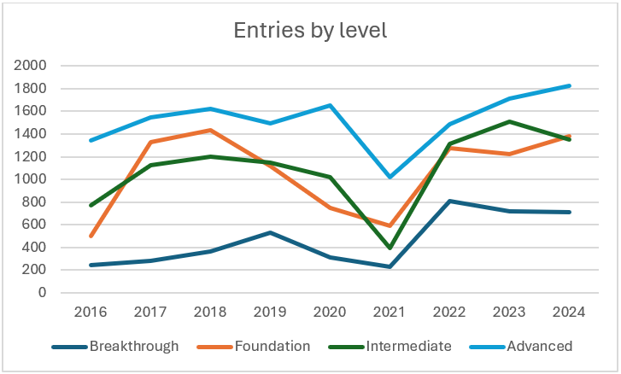
Figure 2: Entries by level 2016-24
State-funded schools entered roughly the same percentage of all competitors as last year (Figure 3), and roughly the same percentages when viewed by level (Figure 4).

Figure 3: State-funded entries as percentage 2016-24

Figure 4: State-funded entries as % by level 2016-24
Girls and boys entered in roughly equal numbers, but with a slight overall balance in favour of girls (Figure 5). But when levels are separated (Figure 6) the picture becomes a little more complex as girls are outnumbered 2:1 by boys at Foundation level, presumably because at this level teachers tend to enter whole classes, and some of our schools are single-sex boys schools.

Figure 5: Girls as a percent of all entries 2016-24

Figure 6: Girls as percent of entries by level 2016-24
More noteworthy is the almost perfect balance between boys and girls in the Advanced competition, which this year showed a fluke 50.00% percentage for girls! This is an important datum because Advanced entries are the result of free choice by the competitors, so the equal balance is evidence that our competition appeals equally to boys and to girls. This is unexpected in the area of language which is traditionally seen as a female preserve.
The choice of levels is one of the features of UKLO of which we are most proud (and which, so far as we know, is unique to UKLO among the countries that have a linguistics olympiad). This allows us to offer the competition to surprisingly young children, as young as Year 4 (i.e. age 8). As expected and intended, the choice of level relates strongly to competitors’ age (Figure 5): Breakthrough clearly dominant at Y4-Y9 (Key Stages 2-3), Foundation at Y8-Y9 (KS3), Intermediate at Y9-12, but especially Y10-Y11 (KS4) and Advanced at Y10-13, but especially Y12-13 (KS5). Alongside these clear tendencies, we are pleased to see that schools use their freedom to enter competitors at any level, regardless of their age. (The figures for R2 are included for completeness, although they are not in fact the result of a free choice.)

 | Breakthrough | Foundation | Intermediate | Advanced | R2
Y4 | 1 | 0 | 0 | 0 | 0
Y5 | 47 | 1 | 0 | 0 | 0
Y6 | 83 | 11 | 7 | 1 | 0
Y7 | 248 | 290 | 7 | 2 | 0
Y8 | 138 | 357 | 6 | 7 | 0
Y9 | 124 | 612 | 215 | 49 | 2
Y10 | 31 | 45 | 650 | 177 | 4
Y11 | 10 | 38 | 264 | 270 | 17
Y12 | 21 | 19 | 171 | 1031 | 39
Y13 | 8 | 3 | 21 | 267 | 24
? | 2 | 6 | 9 | 24 | 2
all | 713 | 1382 | 1349 | 1828 | 88
Figure 7: Entries by age and level in 2024

Round 2
Round 2 is for all the competitors who won a Gold certificate in Round 1 Advanced (Gold certificates go to the top 5% at each level); and the 88 competitors sat Round 2 in their schools. As can be seen from Figure 4’s short line for R2 in the last three years, state-funded schools provided 10% fewer competitors at R2 compared with the R1 Advanced level. Similarly for Figure 6, which shows that girls constituted only a quarter of the R2 competitors, contrasting with half of all Advanced competitors.
On the basis of the Round 2 results, we selected just 8 competitors to attend the training camp, where we selected four for the UK team.

The training camp and post-camp training
As last year, we used our residential event as a training camp. Our host was Magdalen College Oxford (with sessions in the Maison Française); the costs were largely covered by a generous grant from the university’s Linguistics Department. The camp lasted three whole days and was entirely dedicated to training activities, rather than including another formal test. The tutors were Graeme Trousdale, Simi Hellsten and a new face: Daniel Turaev, who volunteered to replace Graeme as one of the two adults accompanying the team to Brazil; so the adults there were Daniel and Simi.
This year we could only afford to send a single team of four competitors to the IOL (International Linguistics Olympiad) competition, which was unusually expensive because of the high cost of flights to Brazil (our first competition in the southern hemisphere).

The International competition (IOL)
The 2024 IOL was held in Brazil. Our team performed extremely strongly, with all four of the competitors winning an award (two Golds, one Bronze and one Honourable Mention) and the team winning the trophy for the team with the highest average individual scores. (This is the second time that we have won this trophy.) This strong performance is encouraging because it confirms that our whole operation is at an international level, in spite of the relative lack of knowledge-about-language in our schools compared with other countries.
In order to celebrate our success in Brazil we have been invited to hold a gathering in the premises of our new sponsor, Convex. (See Finances below.) We expect to be on the 34th floor of their building in The City.

Infrastructure
As last year, the infrastructure for UKLO was largely supplied by past competitors, to whom we’re deeply indebted:
- Simi Hellsten: one of the three Vice-Chairs, Chair of the Problem-creation team, camp tutor and IOL adult.
- Kazune Sato: Marking coordinator for Round 1. (He was in the Japanese olympiad.)
- Eva Neu: Round 2 coordinator. (She was in the German olympiad.)
- Anuraag Vazirani: Camp coordinator.
- Daniel Turaev: Travel coordinator, camp tutor and IOL adult.
- Jack Hodkinson: Portal constructor and manager.
- Neema Kotonya: Website manager.
- Alex Robson: Schools coordinator.
A number of past competitors are also members of the Problem-creation team. The number of volunteers from past years is a measure of the enthusiasm of young people for our competition.

Finances
As the accompanying spreadsheet (available on the same webpage as this report) shows, our finances are still healthy, in spite of the high cost of the IOL in Brazil. This is due to money we have received from our growing list of supporters, in addition to our traditional mainstay of BAAL, LAGB, PhilSoc, ISMLA and the British Academy.
One new supporter is our first corporate sponsor, Convex. This is a new but large insurance company based in the City of London, in whose offices we hope to celebrate our IOL successes. Several of their younger staff are keen to help with our marking.
We have also received one particularly large anonymous donation, which raises our income from donations (from schools and individuals) to about £2,700.

